Time Series Analysis - Bitcoin Competition

Loan Huynh - s3655461

# Introduction

The aim of this project is trying to find the best model for forecasting Bit Coin price in next 10 days.

Dataset is collected from <https://coinmarketcap.com/> website between 27 April 2013 to 24 Feb 2019.

# Data Exploration

*Loading data and library*

# Load libraries  
library(TSA)  
library(fUnitRoots)  
library(forecast)  
library(CombMSC)  
library(lmtest)  
library(fGarch)  
library(rugarch)  
library(tseries)  
source("residual.analysis.R")  
source("TSHandy.r")  
source("MASE.R")  
  
# This function is used to fiting model  
modelfit <- function(garchOrder, armaOrder, data){  
 model <- ugarchspec(variance.model = list(model = "sGARCH", garchOrder = garchOrder),   
 mean.model = list(armaOrder = armaOrder, include.mean = FALSE),   
 distribution.model = "norm")  
 model.fit <- ugarchfit(spec=model,data=data, out.sample = 100)  
 return(model.fit)  
}  
  
  
# sortAIC_garch function is sort Garchmodels based on AIC values  
sortAIC_garch <- function(list_GarchOrder, resdata)  
{  
 rs <- data.frame(matrix(ncol = 2))  
 colnames(rs) <- c("GarchOrder", "AIC")  
 for (i in 1: length(list_GarchOrder))  
 {  
 garchOrder <- sapply(list_GarchOrder,function(x) unlist(x))[,i]  
 model <- garch(resdata, order = garchOrder)  
 aic <- AIC(model)  
 rs[i,] <- list(toString(garchOrder), aic)  
 }  
 return(rs[order(rs$AIC),])  
}  
  
  
# This function transform fitted residuals from forcasting ARIMA+GARCH model into fitted BitCoin Price  
fitted.values <- function(forecastResult, transformed_series)  
{  
 fitted.res <- forecastResult@forecast$seriesFor  
 invdiff <- diffinv(fitted.res)  
 latest_value <- transformed_series[length(transformed_series)]  
 fitted.value.list <- c()  
 for(i in 2:length(invdiff))  
 {  
 trans.fitted.value <- latest_value + invdiff[i]  
 fitted.value.list <- c(fitted.value.list, exp(trans.fitted.value))  
 latest_value <- trans.fitted.value  
 }  
 return(fitted.value.list)  
}  
  
  
#This function create model and return MASE results for 10 forecasts  
checkMASE <- function(model, data_model, data.trans, observed)  
{  
 # model <- modelfit(garchOrder, armaOrder, data_model)  
 forcRes = ugarchforecast(model, data = data_model, n.ahead = 10)  
 predicted_result <- fitted.values(forcRes, data.trans)  
 rs <- MASE(observed,predicted_result)$MASE  
 return(rs)  
}  
  
# Load dataset  
bitcoin <- read.csv("Bitcoin_Historical_Price.csv")  
bitcoin_ts <- data.frame(bitcoin$Close)  
rownames(bitcoin_ts) <- bitcoin$Date  
bitcoin_ts <- ts(as.vector(bitcoin_ts), start = c(2013,27,4), frequency = 365) # Convert Bitcoin price data into Time Series Object  
plot(bitcoin_ts, type= 'o', main="Bit Coin Price Series from 27/04/2013 - 24/02/2019")

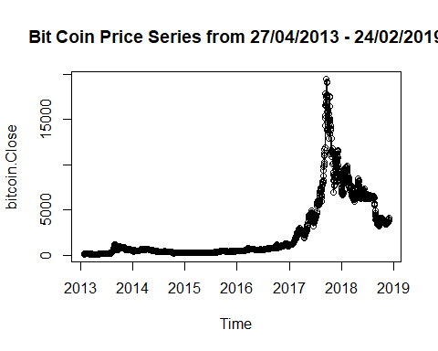

Bit Coin series plot illustrates that there is no seasonality. This series fluctuates from 2013 to 2017 and then go up significantly. It reaches a peak at nearly 20000 USD for some days in the end of 2017. After that it falls considerably in 2018 and 2019. It has succeeding points and changes of variance.

# Scatter plot  
plot(y = bitcoin_ts, x = zlag(bitcoin_ts), main = "Scatter Plot of Bit Coin within Previous Day")

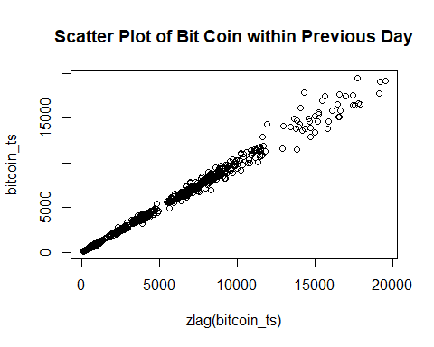

Scatter plot shows a strong relationship between Bit Coin Price and its lag.

acf(bitcoin_ts, na.action = na.pass, main ="ACF plot of Bit Coin series") # ACF Plot

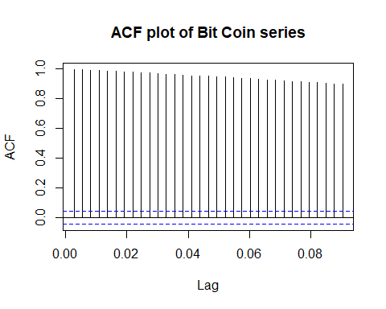

pacf(bitcoin_ts, na.action = na.pass, main = "PACF plot of Bit Coin Series") # PACF plot

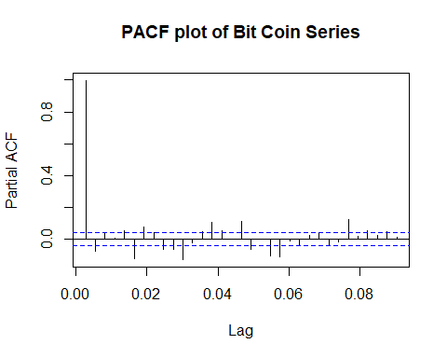

ACF plot has decaying pattern. In conclusion, Bit Coin price is a non-stationary series. In the next parts, transformation and difference are applied to transfer non-stationary series into stationary series.

# Data Transformation and Difference

## Data transformation

Log is applied for transforming data because this series skews to the right in its histogram plot and has positive values.

# Log Transform  
log.bc <- log(bitcoin_ts)  
hist(bitcoin_ts, main = "Histogram of Bit Coin Series before transformation", xlab = "Bit Coin Price", cex.main=1)

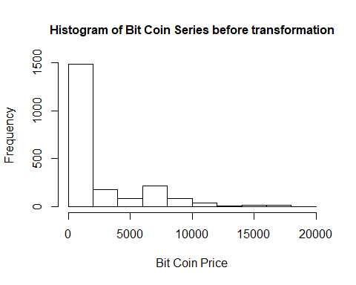

hist(log.bc, main = "Histogram of Bit Coin Series after transformation", xlab = "Log Transform of Bit Coin", cex.main=1)

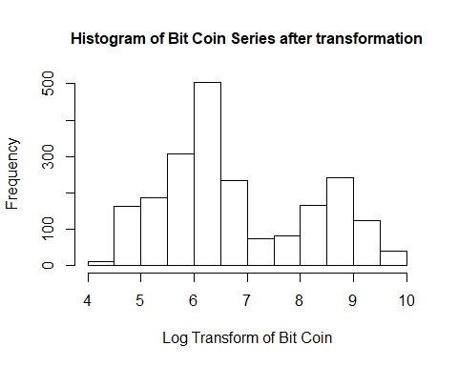

***ACF and PACF of transformed data***

acf(log.bc, na.action = na.pass, main = "ACF of transformed Bit Coin", cex.main= 1)

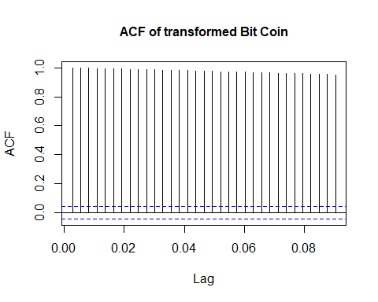

pacf(log.bc, na.action = na.pass, main = "PACF of transformed Bit Coin", cex.main= 1)

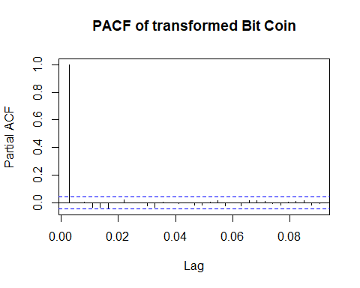

After transformation, the series still got decaying pattern in ACF. It means that it is still a non-stationary series.

ADF Test is applied to validate the stationary of series

ar(diff(log.bc)) # Order 31

##   
## Call:  
## ar(x = diff(log.bc))  
##   
## Coefficients:  
## 1 2 3 4 5 6 7 8   
## -0.0012 -0.0140 0.0069 0.0226 0.0383 0.0607 -0.0215 -0.0010   
## 9 10 11 12 13 14 15 16   
## -0.0042 0.0495 0.0563 -0.0066 0.0058 0.0052 0.0024 -0.0111   
## 17 18 19 20 21 22 23 24   
## 0.0688 0.0064 -0.0117 0.0552 -0.0230 0.0292 -0.0450 -0.0203   
## 25 26 27 28 29 30 31   
## -0.0139 0.0343 0.0198 -0.0436 -0.0376 -0.0472 0.0386   
##   
## Order selected 31 sigma^2 estimated as 0.001853

adfTest(log.bc, lags = 31)

##   
## Title:  
## Augmented Dickey-Fuller Test  
##   
## Test Results:  
## PARAMETER:  
## Lag Order: 31  
## STATISTIC:  
## Dickey-Fuller: 1.0713  
## P VALUE:  
## 0.9232   
##   
## Description:  
## Sun Jun 09 16:01:45 2019 by user: loanh

The p-value of ADF Test is 0.9232 larger than 0.05. Therefore, Null hypothesis cannot be rejected. It means that series is non-stationary series.

***Ljung-Box Test***

Box.test(x = log.bc, type = "Ljung-Box")

##   
## Box-Ljung test  
##   
## data: log.bc  
## X-squared = 2127.9, df = 1, p-value < 2.2e-16

The p-value is less than 5% of significance level. Therefore, null hypothesis of independence is rejected. It means that the series values are dependents or correlated.

## Data Difference

Apply first difference for transformed series.

diff.log.bc <- (diff(log.bc, difference =1))   
plot(diff.log.bc, type= 'o', main = "First difference of Bit Coin series")  
abline(h=0)

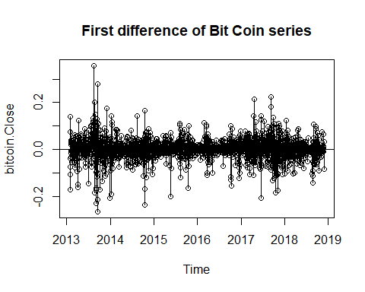

The above series plot looks like moving average model. Apply ADF Test for this series

# ADF Test  
ar(diff(diff.log.bc), na.action = na.pass) # Order is 32

##   
## Call:  
## ar(x = diff(diff.log.bc), na.action = na.pass)  
##   
## Coefficients:  
## 1 2 3 4 5 6 7 8   
## -0.9421 -0.9044 -0.8482 -0.7827 -0.7065 -0.6114 -0.6052 -0.5769   
## 9 10 11 12 13 14 15 16   
## -0.5536 -0.4762 -0.3997 -0.3867 -0.3642 -0.3395 -0.3179 -0.3147   
## 17 18 19 20 21 22 23 24   
## -0.2289 -0.2100 -0.2085 -0.1389 -0.1495 -0.1071 -0.1405 -0.1441   
## 25 26 27 28 29 30 31 32   
## -0.1403 -0.0856 -0.0503 -0.0772 -0.0950 -0.1201 -0.0560 -0.0465   
##   
## Order selected 32 sigma^2 estimated as 0.001961

adfTest(diff.log.bc, lags = 32)

## Warning in adfTest(diff.log.bc, lags = 32): p-value smaller than printed p-  
## value

##   
## Title:  
## Augmented Dickey-Fuller Test  
##   
## Test Results:  
## PARAMETER:  
## Lag Order: 32  
## STATISTIC:  
## Dickey-Fuller: -7.4259  
## P VALUE:  
## 0.01   
##   
## Description:  
## Sun Jun 09 16:01:45 2019 by user: loanh

With order of lag is 32, the differenced series becomes stationary

***Apply McLeod-Li Test***

McLeod.Li.test(y=diff.log.bc, main="McLeod-Li Test Statistics for Bit Coin Returns")

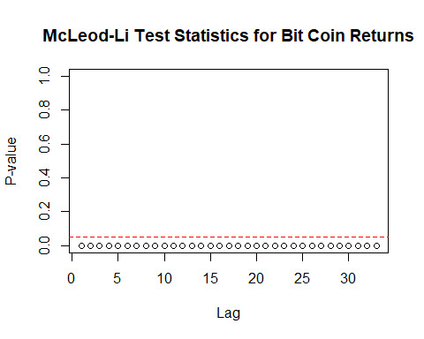

It is clearly observed in McLeod-Li Test result that all lags are significant at 5% significance level. It implies the existence of volatility clustering.

***Q-Q plot***

qqnorm(diff.log.bc, main="Q-Q plot of 1st Difference Bit Coint Price", cex.main= 1)  
qqline(diff.log.bc, col="red")

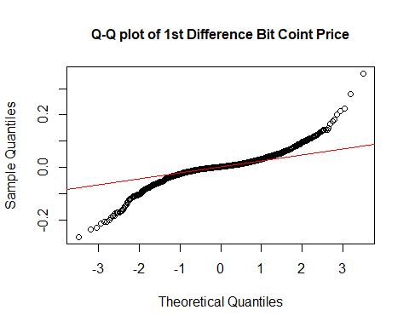

shapiro.test(diff.log.bc)

##   
## Shapiro-Wilk normality test  
##   
## data: diff.log.bc  
## W = 0.88509, p-value < 2.2e-16

Q-Q normal plot shows that there are so many outliers at both tails. The p-value of Shapiro-Wilk test is less than 0.05. It implies that the first difference of bit coin violates normality assumption.

***ACF and PACF plots***

acf(diff.log.bc , na.action = na.pass, main = "ACF for 1st difference of series", cex.main= 1)

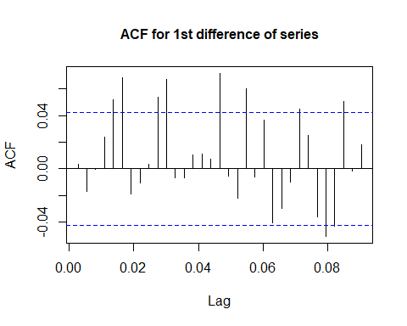

pacf(diff.log.bc , na.action = na.pass, main = "PACF for 1st difference of series", cex.main= 1)

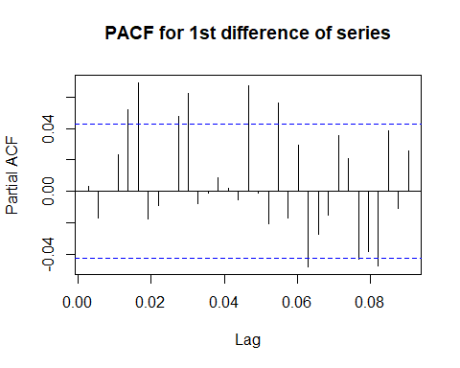

There are so many significant lags in both ACF and PACF plots. There are no distinct between both plots. Due to stationarity and changes of variances problems in original series. In this report, ARMA + GARCH model is applied.

# Data Modeling

## ARIMA model

***EACF***

eacf(diff.log.bc)

## AR/MA  
## 0 1 2 3 4 5 6 7 8 9 10 11 12 13  
## 0 o o o o x x o o o x x o o o   
## 1 x o o o o x o o o o x o o o   
## 2 o x o o o x o o o o x o o o   
## 3 o x o o o x o o o o x o o o   
## 4 x x o x o x o o o o x o o o   
## 5 x x x x x o o o o o x o o o   
## 6 x x x x x o o o o o o o o o   
## 7 x x o x x x x o o o o o o o

EACF suggests possibles models like ARIMA(0,1,11), ARIMA(6,1,7), ARIMA(6,1,8), ARIMA(7,1,7)

***BIC Table***

bic = armasubsets(y=diff.log.bc,nar=13,nma=13,y.name='test',ar.method='ols')

## Warning in leaps.setup(x, y, wt = wt, nbest = nbest, nvmax = nvmax,  
## force.in = force.in, : 2 linear dependencies found

## Reordering variables and trying again:

plot(bic)

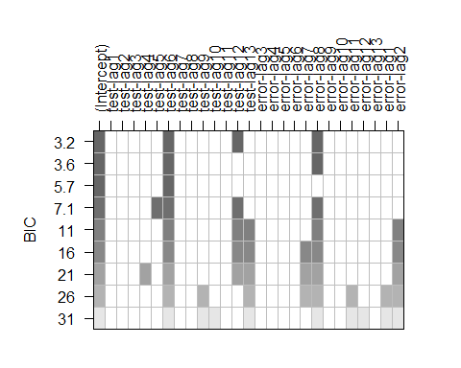

BIC table suggests ARIMA(6,1,8), ARIMA(12,1,8)

The set of possible ARIMA models is {ARIMA(0,1,11), ARIMA(6,1,7), ARIMA(6,1,8), ARIMA(7,1,7), ARIMA(12,1,8)}

### Parameter Estimation

Maximum Likelihood method is considered to estimate parameters

armaList <- list(c(0,1,11), c(6,1,7), c(6,1,8) ,c(7,1,7),c(12,1,8))  
armaEstimation <- myCandidate(bitcoin_ts, orderList = armaList, methodType = "ML")  
armaEstimation$IC

## p d q AIC AICc BIC  
## 5 12 1 8 28951.50 28951.94 29070.44  
## 3 6 1 8 28992.29 28992.51 29077.24  
## 2 6 1 7 29137.67 29137.87 29216.96  
## 4 7 1 7 29139.09 29139.32 29224.04  
## 1 0 1 11 29141.98 29142.13 29209.94

ARIMA(12,1,8) got smallest AIC and BIC result.

***Coefficient Test***

Coefficient Test is applied for all possible models based on AIC and BIC result orderly.

*ARIMA(12,1,8)*

arima.1218 <- arima(bitcoin_ts, order = c(12,1,8))  
coeftest(arima.1218)

##   
## z test of coefficients:  
##   
## Estimate Std. Error z value Pr(>|z|)   
## ar1 0.336787 0.081830 4.1157 3.860e-05 ***  
## ar2 0.049864 0.079912 0.6240 0.5326353   
## ar3 -0.236650 0.040764 -5.8054 6.422e-09 ***  
## ar4 0.285492 0.036289 7.8672 3.628e-15 ***  
## ar5 -0.309696 0.038398 -8.0655 7.295e-16 ***  
## ar6 -0.563696 0.048624 -11.5929 < 2.2e-16 ***  
## ar7 0.379273 0.065010 5.8341 5.408e-09 ***  
## ar8 -0.185615 0.072869 -2.5472 0.0108578 *   
## ar9 -0.026413 0.026000 -1.0159 0.3096754   
## ar10 0.124967 0.023953 5.2172 1.817e-07 ***  
## ar11 0.092357 0.026588 3.4736 0.0005135 ***  
## ar12 -0.228153 0.026211 -8.7046 < 2.2e-16 ***  
## ma1 -0.300932 0.083136 -3.6197 0.0002949 ***  
## ma2 -0.116125 0.080528 -1.4421 0.1492870   
## ma3 0.252682 0.041717 6.0570 1.387e-09 ***  
## ma4 -0.307463 0.031663 -9.7105 < 2.2e-16 ***  
## ma5 0.470048 0.030140 15.5956 < 2.2e-16 ***  
## ma6 0.569370 0.048667 11.6994 < 2.2e-16 ***  
## ma7 -0.448122 0.072671 -6.1664 6.985e-10 ***  
## ma8 0.328366 0.078303 4.1935 2.747e-05 ***  
## ---  
## Signif. codes: 0 '***' 0.001 '**' 0.01 '*' 0.05 '.' 0.1 ' ' 1

There are only three coefficients of ar2, ar9 and ma2 not significant at 5%

*ARIMA(6,1,8)*

arima.618 <- arima(bitcoin_ts, order = c(6,1,8))  
coeftest(arima.618)

##   
## z test of coefficients:  
##   
## Estimate Std. Error z value Pr(>|z|)   
## ar1 0.875232 0.093195 9.3914 < 2.2e-16 ***  
## ar2 0.138037 0.092949 1.4851 0.137520   
## ar3 -0.666490 0.090507 -7.3640 1.785e-13 ***  
## ar4 -0.259465 0.093069 -2.7879 0.005306 **   
## ar5 0.547189 0.131103 4.1737 2.997e-05 ***  
## ar6 -0.375159 0.073673 -5.0922 3.538e-07 ***  
## ma1 -0.844764 0.092324 -9.1500 < 2.2e-16 ***  
## ma2 -0.225483 0.091845 -2.4550 0.014088 *   
## ma3 0.720366 0.096541 7.4618 8.535e-14 ***  
## ma4 0.279387 0.101792 2.7447 0.006057 **   
## ma5 -0.399955 0.140533 -2.8460 0.004427 **   
## ma6 0.225664 0.071024 3.1773 0.001487 **   
## ma7 -0.015076 0.040233 -0.3747 0.707866   
## ma8 0.218731 0.033925 6.4475 1.137e-10 ***  
## ---  
## Signif. codes: 0 '***' 0.001 '**' 0.01 '*' 0.05 '.' 0.1 ' ' 1

Most of coefficients for this model are significant, except ma7 and ar2.

*ARIMA(6,1,7)*

arima.617 <- arima(bitcoin_ts, order = c(6,1,7))  
coeftest(arima.617)

##   
## z test of coefficients:  
##   
## Estimate Std. Error z value Pr(>|z|)   
## ar1 0.3579926 0.0709701 5.0443 4.552e-07 ***  
## ar2 -0.3935201 0.1276471 -3.0829 0.0020501 **   
## ar3 -0.6191569 0.1016227 -6.0927 1.110e-09 ***  
## ar4 -0.2848556 0.0995241 -2.8622 0.0042074 **   
## ar5 0.2255639 0.0979622 2.3026 0.0213036 *   
## ar6 -0.7925021 0.0674990 -11.7409 < 2.2e-16 ***  
## ma1 -0.2814151 0.0740698 -3.7993 0.0001451 ***  
## ma2 0.3439157 0.1385974 2.4814 0.0130867 *   
## ma3 0.7001192 0.1268680 5.5185 3.419e-08 ***  
## ma4 0.2505341 0.1312875 1.9083 0.0563542 .   
## ma5 -0.1123529 0.1382334 -0.8128 0.4163463   
## ma6 0.7000980 0.1207694 5.7970 6.752e-09 ***  
## ma7 -0.0097353 0.0545837 -0.1784 0.8584437   
## ---  
## Signif. codes: 0 '***' 0.001 '**' 0.01 '*' 0.05 '.' 0.1 ' ' 1

Most of coefficients for this model are significant, except ma4, ma5 and ma7

*ARIMA(7,1,7)*

arima.717 <- arima(bitcoin_ts, order = c(7,1,7))  
coeftest(arima.717)

##   
## z test of coefficients:  
##   
## Estimate Std. Error z value Pr(>|z|)   
## ar1 -0.28178 0.25733 -1.0950 0.273507   
## ar2 -0.25295 0.21251 -1.1903 0.233938   
## ar3 -0.20868 0.24150 -0.8641 0.387525   
## ar4 -0.11402 0.24763 -0.4604 0.645211   
## ar5 0.56828 0.24461 2.3232 0.020169 *   
## ar6 0.23785 0.22824 1.0421 0.297355   
## ar7 0.31009 0.12941 2.3962 0.016564 *   
## ma1 0.37880 0.25226 1.5016 0.133198   
## ma2 0.26988 0.22240 1.2135 0.224946   
## ma3 0.25043 0.25462 0.9836 0.325334   
## ma4 0.10500 0.26628 0.3943 0.693334   
## ma5 -0.45251 0.25764 -1.7563 0.079029 .   
## ma6 -0.31727 0.22940 -1.3830 0.166659   
## ma7 -0.40238 0.13319 -3.0212 0.002518 **  
## ---  
## Signif. codes: 0 '***' 0.001 '**' 0.01 '*' 0.05 '.' 0.1 ' ' 1

The majority of coefficients in this model is not significant.

*ARIMA(0,1,11)*

arima.0111 <- arima(bitcoin_ts, order = c(0,1,11))  
coeftest(arima.0111)

##   
## z test of coefficients:  
##   
## Estimate Std. Error z value Pr(>|z|)   
## ma1 0.0913312 0.0221350 4.1261 3.690e-05 ***  
## ma2 -0.0048507 0.0219150 -0.2213 0.82482   
## ma3 0.0158047 0.0221970 0.7120 0.47645   
## ma4 -0.0307127 0.0231146 -1.3287 0.18394   
## ma5 0.1264469 0.0239024 5.2901 1.222e-07 ***  
## ma6 -0.0275749 0.0260263 -1.0595 0.28937   
## ma7 -0.0694753 0.0272005 -2.5542 0.01064 *   
## ma8 0.0651726 0.0277051 2.3524 0.01865 *   
## ma9 0.0130509 0.0242927 0.5372 0.59111   
## ma10 0.1183611 0.0208654 5.6726 1.407e-08 ***  
## ma11 0.0592755 0.0237377 2.4971 0.01252 *   
## ---  
## Signif. codes: 0 '***' 0.001 '**' 0.01 '*' 0.05 '.' 0.1 ' ' 1

Coefficients for ma2, ma3, ma4, ma6, ma9 in arima (0,1,11) are not significant.

From coefficients test result and AIC/BIC table, the set of arima model {ARIMA(6,1,8), ARIMA(12,1,8)} is considered for diagnostics check.

### MODEL DIAGNOTICS

***ARIMA(6,1,8)***

residual.analysis(model = arima.618, class = "ARIMA")

##   
## Shapiro-Wilk normality test  
##   
## data: res.model  
## W = 0.55067, p-value < 2.2e-16

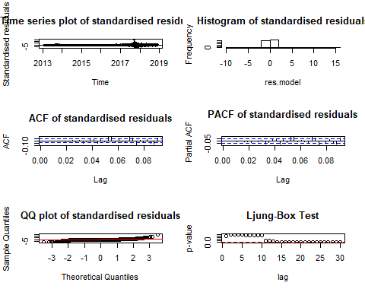

***ARIMA(12,1,8)***

residual.analysis(model = arima.1218, class = "ARIMA")

##   
## Shapiro-Wilk normality test  
##   
## data: res.model  
## W = 0.56365, p-value < 2.2e-16

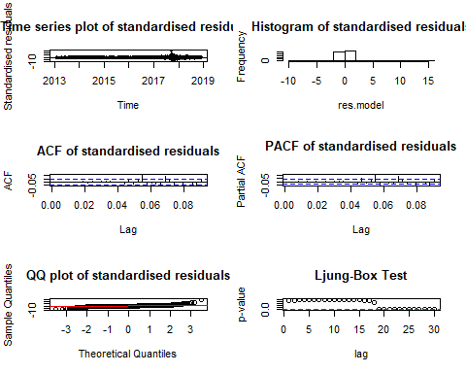

It is clearly to see that both ARIMA(12,1,8) and ARIMA(6,1,8) failed in Ljung-Box Test and violate normality of residuals. In next part, garch models are selected based on residuals of two these models.

## GARCH

##### ARIMA(6,1,8)

*Absolute transform*

res.618 <- arima.618$residuals  
# Apply absolute transform  
ab.res.618 <- abs(res.618)  
# ACF and PACF plots  
acf(ab.res.618, ci.type="ma",main="ACF plot for absolute residual series ARIMA(6,1,8)", cex.main= 1)

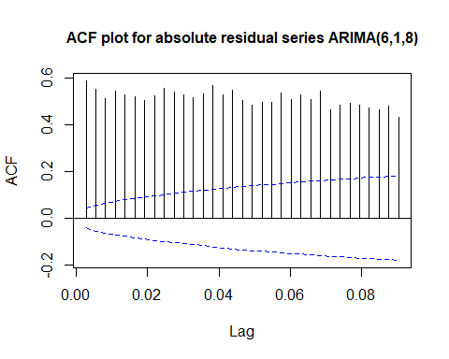

pacf(ab.res.618, main="PACF plot for absolute residual series ARIMA(6,1,8)", cex.main= 1)

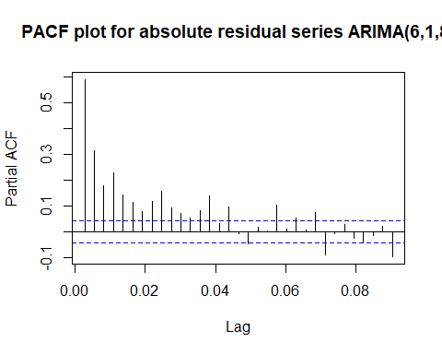

eacf(ab.res.618)

## AR/MA  
## 0 1 2 3 4 5 6 7 8 9 10 11 12 13  
## 0 x x x x x x x x x x x x x x   
## 1 x o x x o o x o x o o o o x   
## 2 x o x x x o o o x o o o o x   
## 3 x x x x o o o o x o o o o x   
## 4 x x o x x o o o x o o o o x   
## 5 x x o x x o x o o o o o o x   
## 6 x x x x x x x o o o o o o x   
## 7 x x x o x x o o o o o o o x

No AR/MA is suggested from eacf of absolute residuals

***Squared Transform***

sq.res.618 <- res.618^2  
acf(sq.res.618, ci.type="ma",main="ACF plot for square residual series ARIMA(6,1,8)", cex.main= 1)

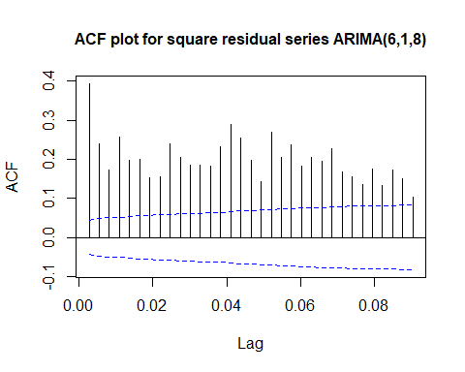

pacf(sq.res.618, main="PACF plot for square residual series ARIMA(6,1,8)", cex.main= 1)

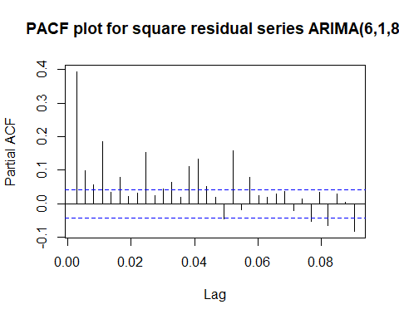

eacf(sq.res.618)

## AR/MA  
## 0 1 2 3 4 5 6 7 8 9 10 11 12 13  
## 0 x x x x x x x x x x x x x x   
## 1 x x x x x x o o x o o o o o   
## 2 x o x x x o o x x o o o o o   
## 3 x x x x x o o o x o o o o o   
## 4 x x o o o o x x x o o o o o   
## 5 x x x o x x x o o o o o o o   
## 6 x x o o x x x o o x o o o o   
## 7 x o x o x o x o o x o o o o

EACF plot suggests ARMA(5,7), ARMA(6,7), ARMA(5,8). The possible GARCH models are GARCH(7,5), GARCH(7,6), GARCH(8,5).

list_garchOrder <- list(c(7,5), c(7,6), c(8,5))  
sortAIC_garch(list_garchOrder, arima.618$residuals)

## GarchOrder AIC  
## 2 7, 6 26391.62  
## 3 8, 5 26419.38  
## 1 7, 5 26591.81

GARCH(7,6) has smallest AIC value in comparison with other models with residuals of ARIMA(6,1,8).

##### ARIMA(12,1,8)

res.1218 <- arima.1218$residuals  
ab.res.1218 <- abs(res.1218)  
# ACF and PACF plots  
acf(ab.res.1218, ci.type="ma",main="ACF plot for absolute residual series ARIMA(12,1,8)", cex.main= 1)

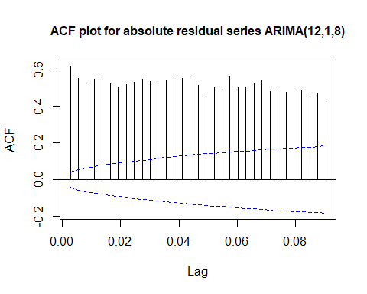

pacf(ab.res.1218, main="PACF plot for absolute residual series ARIMA(12,1,8)", cex.main= 1)

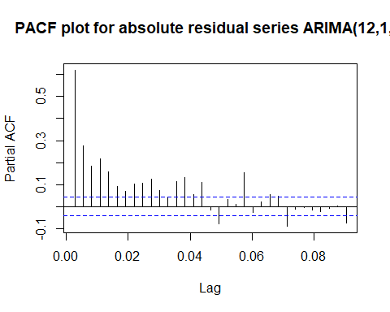

eacf(ab.res.1218)

## AR/MA  
## 0 1 2 3 4 5 6 7 8 9 10 11 12 13  
## 0 x x x x x x x x x x x x x x   
## 1 x x x o o o o o o o o x o x   
## 2 x x x o x o o o o o o x o x   
## 3 x x x o o o o o o o o o o x   
## 4 x x x x o o o o o o o o o x   
## 5 x x x x x o x o o o o o o o   
## 6 x x x x o x o o o o o o o x   
## 7 x x x x x x x o o o o o o x

EACF suggest ARMA(5,7), ARMA(6,7), ARMA(5,8). The possible GARCH models are GARCH(7,5), GARCH(7,6), GARCH(8,5)

sq.res.1218 <- res.1218^2  
eacf(sq.res.1218)

## AR/MA  
## 0 1 2 3 4 5 6 7 8 9 10 11 12 13  
## 0 x x x x x x x x x x x x x x   
## 1 x x x x o o x o x o o o o o   
## 2 x o x x x o o x x o o o o o   
## 3 x x x x x o o x x o o o o o   
## 4 x x x x x o o x o o o o o o   
## 5 x x x o x x x x o o o o o o   
## 6 x x x o x x o o o x o o o o   
## 7 x o x o x x o o o x o o o o

EACF suggests ARMA(1,9), ARMA(4,8), ARMA(5,8), ARMA(4,9) . The possible GARCH models are GARCH(9,1), GARCH(8,4), GARCH(8,5), GARCH(9,4)

The set of possible GARCH model for residuals of ARIMA(12,1,8): {GARCH(7,5), GARCH(7,6), GARCH(8,5),GARCH(9,1), GARCH(8,4), GARCH(9,4) }

list_garchOrder1218 <- list(c(7,5), c(7,6), c(8,5), c(9,1), c(8,4), c(9,4))  
sortAIC_garch(list_garchOrder1218, arima.1218$residuals)

## GarchOrder AIC  
## 2 7, 6 26365.62  
## 3 8, 5 26389.47  
## 6 9, 4 26521.77  
## 1 7, 5 26560.56  
## 5 8, 4 26695.10  
## 4 9, 1 27195.88

GARCH(7,6) has smallest AIC value in comparision with other models with residuals of ARIMA(12,1,8).

## ARIMA + GARCH

Some combine possible models are considered as below

#### ARIMA(6,1,8)

##### ARIMA(6,1,8) + GARCH(7,6)

model.618_76 <- modelfit(c(7,6), c(6,8), diff.log.bc)  
model.618_76

##   
## *---------------------------------*  
## * GARCH Model Fit *  
## *---------------------------------*  
##   
## Conditional Variance Dynamics   
## -----------------------------------  
## GARCH Model : sGARCH(7,6)  
## Mean Model : ARFIMA(6,0,8)  
## Distribution : norm   
##   
## Optimal Parameters  
## ------------------------------------  
## Estimate Std. Error t value Pr(>|t|)  
## ar1 -0.151572 0.032564 -4.654635 0.000003  
## ar2 0.117641 0.044735 2.629716 0.008546  
## ar3 -0.488581 0.029406 -16.614843 0.000000  
## ar4 0.055808 0.039727 1.404775 0.160088  
## ar5 -0.205361 0.042630 -4.817322 0.000001  
## ar6 -0.849000 0.013807 -61.490958 0.000000  
## ma1 0.148148 0.042081 3.520524 0.000431  
## ma2 -0.126905 0.045978 -2.760121 0.005778  
## ma3 0.499325 0.021420 23.311055 0.000000  
## ma4 -0.061440 0.036243 -1.695223 0.090033  
## ma5 0.174393 0.038930 4.479677 0.000007  
## ma6 0.905007 0.000752 1203.518496 0.000000  
## ma7 -0.004955 0.026574 -0.186460 0.852084  
## ma8 -0.026451 0.023087 -1.145708 0.251916  
## omega 0.000084 0.000010 8.099854 0.000000  
## alpha1 0.149665 0.022259 6.723822 0.000000  
## alpha2 0.046510 0.007753 5.998621 0.000000  
## alpha3 0.057408 0.021811 2.632104 0.008486  
## alpha4 0.000000 0.001685 0.000013 0.999990  
## alpha5 0.167803 0.024220 6.928214 0.000000  
## alpha6 0.000000 0.021414 0.000000 1.000000  
## alpha7 0.000000 0.045593 0.000000 1.000000  
## beta1 0.000000 0.150701 0.000000 1.000000  
## beta2 0.000000 0.130693 0.000000 1.000000  
## beta3 0.000000 0.119215 0.000000 1.000000  
## beta4 0.064456 0.025830 2.495427 0.012581  
## beta5 0.506628 0.050888 9.955742 0.000000  
## beta6 0.000000 0.015112 0.000001 0.999999  
##   
## Robust Standard Errors:  
## Estimate Std. Error t value Pr(>|t|)  
## ar1 -0.151572 0.036658 -4.13476 0.000036  
## ar2 0.117641 0.083603 1.40715 0.159384  
## ar3 -0.488581 0.057084 -8.55893 0.000000  
## ar4 0.055808 0.062910 0.88710 0.375025  
## ar5 -0.205361 0.085028 -2.41520 0.015726  
## ar6 -0.849000 0.020142 -42.14972 0.000000  
## ma1 0.148148 0.053467 2.77081 0.005592  
## ma2 -0.126905 0.075026 -1.69148 0.090746  
## ma3 0.499325 0.047738 10.45963 0.000000  
## ma4 -0.061440 0.057752 -1.06387 0.287388  
## ma5 0.174393 0.069878 2.49567 0.012572  
## ma6 0.905007 0.001119 808.52598 0.000000  
## ma7 -0.004955 0.031082 -0.15942 0.873341  
## ma8 -0.026451 0.026028 -1.01624 0.309513  
## omega 0.000084 0.000070 1.20181 0.229436  
## alpha1 0.149665 0.050377 2.97089 0.002969  
## alpha2 0.046510 0.055518 0.83774 0.402178  
## alpha3 0.057408 0.045147 1.27158 0.203521  
## alpha4 0.000000 0.074520 0.00000 1.000000  
## alpha5 0.167803 0.059438 2.82315 0.004755  
## alpha6 0.000000 0.149395 0.00000 1.000000  
## alpha7 0.000000 0.181235 0.00000 1.000000  
## beta1 0.000000 0.321297 0.00000 1.000000  
## beta2 0.000000 0.543262 0.00000 1.000000  
## beta3 0.000000 0.570375 0.00000 1.000000  
## beta4 0.064456 0.315186 0.20450 0.837961  
## beta5 0.506628 0.180456 2.80748 0.004993  
## beta6 0.000000 0.340906 0.00000 1.000000  
##   
## LogLikelihood : 3856.091   
##   
## Information Criteria  
## ------------------------------------  
##   
## Akaike -3.7734  
## Bayes -3.6959  
## Shibata -3.7738  
## Hannan-Quinn -3.7449  
##   
## Weighted Ljung-Box Test on Standardized Residuals  
## ------------------------------------  
## statistic p-value  
## Lag[1] 8.838 0.002951  
## Lag[2*(p+q)+(p+q)-1][41] 36.889 0.000000  
## Lag[4*(p+q)+(p+q)-1][69] 49.818 0.001138  
## d.o.f=14  
## H0 : No serial correlation  
##   
## Weighted Ljung-Box Test on Standardized Squared Residuals  
## ------------------------------------  
## statistic p-value  
## Lag[1] 1.326 0.2495  
## Lag[2*(p+q)+(p+q)-1][38] 12.125 0.9432  
## Lag[4*(p+q)+(p+q)-1][64] 19.922 0.9844  
## d.o.f=13  
##

Optimal parameters in this model shows that omega, alpha1, alpha2, alpha3, alpha5, beta4 and beta5 are siginifcant at 5% level.

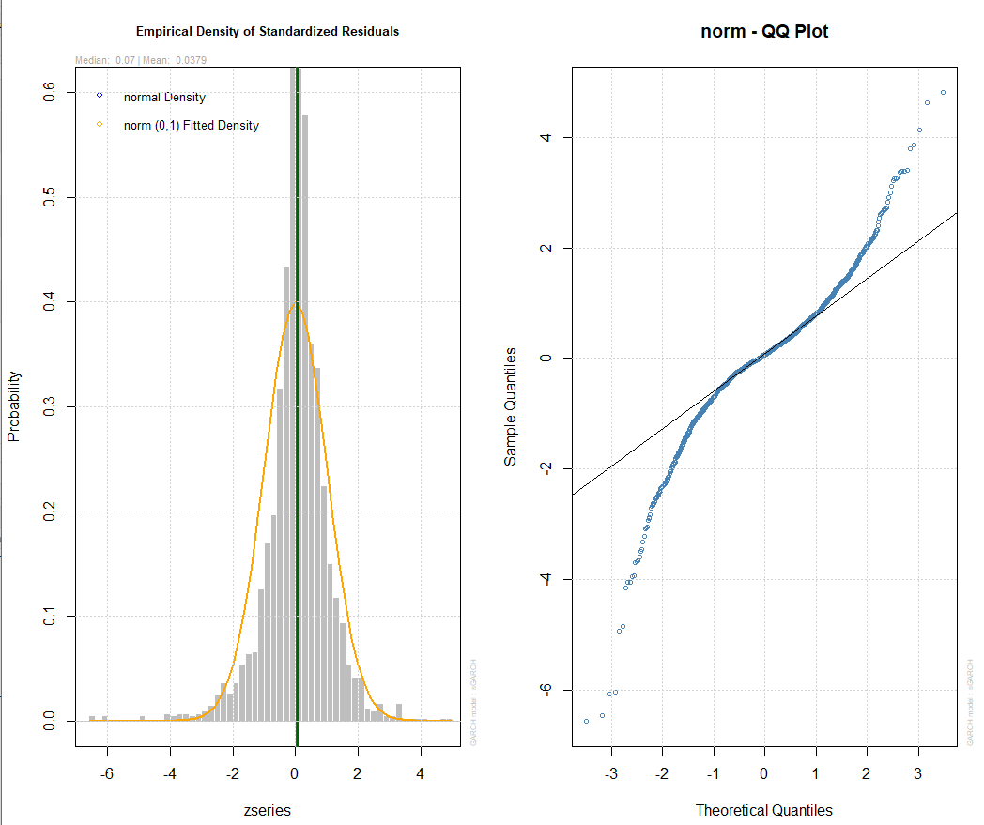

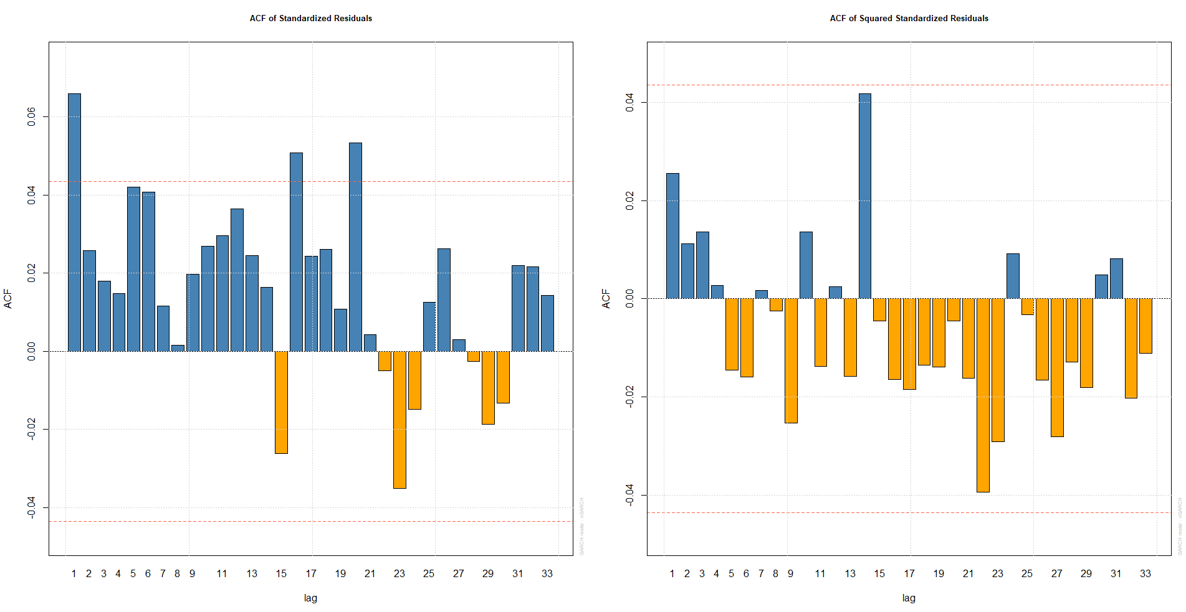

##### ARIMA(6,1,8) + GARCH(8,5)

model.618_85 <- modelfit(c(8,5), c(6,8), diff.log.bc)  
model.618_85

##   
## *---------------------------------*  
## * GARCH Model Fit *  
## *---------------------------------*  
##   
## Conditional Variance Dynamics   
## -----------------------------------  
## GARCH Model : sGARCH(8,5)  
## Mean Model : ARFIMA(6,0,8)  
## Distribution : norm   
##   
## Optimal Parameters  
## ------------------------------------  
## Estimate Std. Error t value Pr(>|t|)  
## ar1 -0.541081 0.000119 -4.5393e+03 0.000000  
## ar2 0.427888 0.000102 4.2098e+03 0.000000  
## ar3 -0.311620 0.000083 -3.7427e+03 0.000000  
## ar4 0.011588 0.000097 1.1929e+02 0.000000  
## ar5 1.019275 0.000223 4.5657e+03 0.000000  
## ar6 0.397696 0.000105 3.7710e+03 0.000000  
## ma1 0.566747 0.000103 5.5176e+03 0.000000  
## ma2 -0.416867 0.000095 -4.3959e+03 0.000000  
## ma3 0.310334 0.000101 3.0735e+03 0.000000  
## ma4 -0.000351 0.001049 -3.3452e-01 0.737986  
## ma5 -1.048153 0.000391 -2.6805e+03 0.000000  
## ma6 -0.400462 0.000176 -2.2780e+03 0.000000  
## ma7 -0.005004 0.000417 -1.2012e+01 0.000000  
## ma8 -0.029713 0.000127 -2.3398e+02 0.000000  
## omega 0.000084 0.000041 2.0665e+00 0.038779  
## alpha1 0.137185 0.025181 5.4480e+00 0.000000  
## alpha2 0.049521 0.021596 2.2931e+00 0.021843  
## alpha3 0.039190 0.020594 1.9030e+00 0.057042  
## alpha4 0.000000 0.015349 3.0000e-06 0.999997  
## alpha5 0.161144 0.029213 5.5161e+00 0.000000  
## alpha6 0.000000 0.105916 0.0000e+00 1.000000  
## alpha7 0.000000 0.053343 0.0000e+00 1.000000  
## alpha8 0.000000 0.021971 0.0000e+00 1.000000  
## beta1 0.000000 0.133192 0.0000e+00 1.000000  
## beta2 0.000000 0.069725 0.0000e+00 1.000000  
## beta3 0.000000 0.086530 0.0000e+00 1.000000  
## beta4 0.075316 0.012566 5.9935e+00 0.000000  
## beta5 0.522803 0.060268 8.6746e+00 0.000000  
##   
## Robust Standard Errors:  
## Estimate Std. Error t value Pr(>|t|)  
## ar1 -0.541081 0.001404 -3.8542e+02 0.000000  
## ar2 0.427888 0.001045 4.0952e+02 0.000000  
## ar3 -0.311620 0.000628 -4.9606e+02 0.000000  
## ar4 0.011588 0.000148 7.8449e+01 0.000000  
## ar5 1.019275 0.002797 3.6445e+02 0.000000  
## ar6 0.397696 0.000846 4.7013e+02 0.000000  
## ma1 0.566747 0.000054 1.0507e+04 0.000000  
## ma2 -0.416867 0.000188 -2.2141e+03 0.000000  
## ma3 0.310334 0.000369 8.4179e+02 0.000000  
## ma4 -0.000351 0.035831 -9.7910e-03 0.992188  
## ma5 -1.048153 0.006730 -1.5575e+02 0.000000  
## ma6 -0.400462 0.000811 -4.9365e+02 0.000000  
## ma7 -0.005004 0.027015 -1.8522e-01 0.853055  
## ma8 -0.029713 0.004599 -6.4604e+00 0.000000  
## omega 0.000084 0.000311 2.6943e-01 0.787596  
## alpha1 0.137185 0.083171 1.6494e+00 0.099058  
## alpha2 0.049521 0.084291 5.8750e-01 0.556865  
## alpha3 0.039190 0.063041 6.2165e-01 0.534169  
## alpha4 0.000000 0.048665 1.0000e-06 0.999999  
## alpha5 0.161144 0.103171 1.5619e+00 0.118309  
## alpha6 0.000000 0.889684 0.0000e+00 1.000000  
## alpha7 0.000000 0.458733 0.0000e+00 1.000000  
## alpha8 0.000000 0.092953 0.0000e+00 1.000000  
## beta1 0.000000 0.984905 0.0000e+00 1.000000  
## beta2 0.000000 0.280333 0.0000e+00 1.000000  
## beta3 0.000000 0.185010 0.0000e+00 1.000000  
## beta4 0.075316 0.213495 3.5278e-01 0.724254  
## beta5 0.522803 0.371560 1.4070e+00 0.159413  
##   
## LogLikelihood : 3863.108   
##   
## Information Criteria  
## ------------------------------------  
##   
## Akaike -3.7803  
## Bayes -3.7028

Optimal parameters in this model shows that omega, alpha1, alpha2, alpha5, beta4 and beta5 are siginifcant at 5% level.

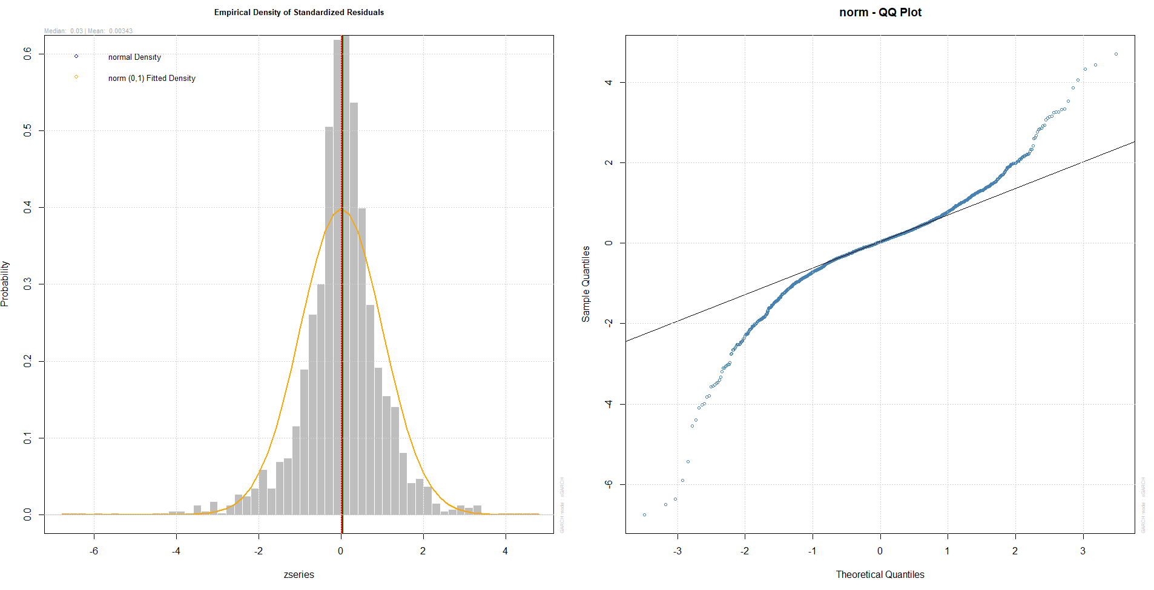

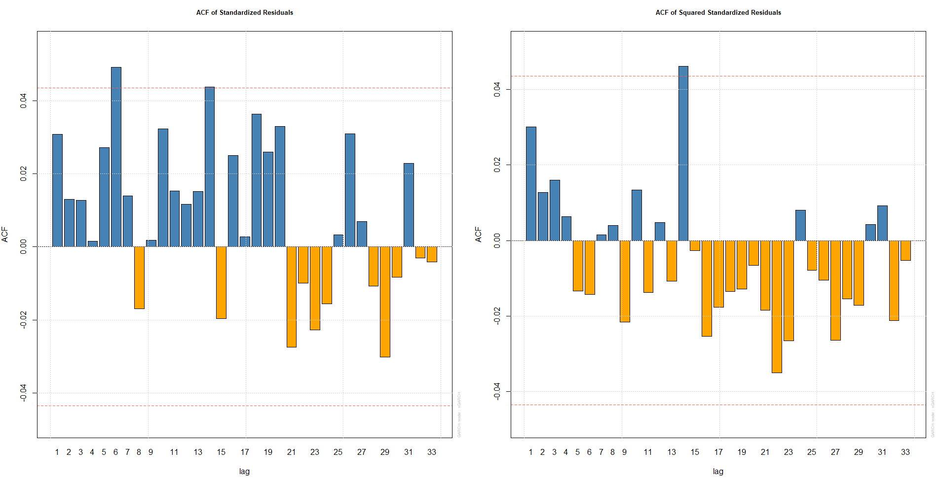

Looking at Q-Q plot between two above models, there are still many points at both tails. However ACF Plots show that ARIMA(6,1,8) + GARCH(7,6) looks better than the other.

As a result, ARIMA(6,1,8) + GARCH(7,6) is the suitable model for residuals of ARIMA(6,1,8).

#### ARIMA(12,1,8)

##### ARIMA(12,1,8) + GARCH(7,5)

model.1218_75 <- modelfit(c(7,5), c(12,8), diff.log.bc)  
model.1218_75

##   
## *---------------------------------*  
## * GARCH Model Fit *  
## *---------------------------------*  
##   
## Conditional Variance Dynamics   
## -----------------------------------  
## GARCH Model : sGARCH(7,5)  
## Mean Model : ARFIMA(12,0,8)  
## Distribution : norm   
##   
## Optimal Parameters  
## ------------------------------------  
## Estimate Std. Error t value Pr(>|t|)  
## ar1 0.318825 0.023811 13.38989 0.000000  
## ar2 -0.912131 0.021884 -41.67957 0.000000  
## ar3 0.768702 0.026262 29.27019 0.000000  
## ar4 -0.496245 0.030571 -16.23269 0.000000  
## ar5 0.902116 0.026042 34.64058 0.000000  
## ar6 -0.237092 0.031407 -7.54914 0.000000  
## ar7 0.348885 0.031304 11.14496 0.000000  
## ar8 0.265777 0.028491 9.32855 0.000000  
## ar9 -0.060022 0.026587 -2.25755 0.023974  
## ar10 0.038951 0.030054 1.29604 0.194961  
## ar11 -0.044153 0.020279 -2.17726 0.029461  
## ar12 0.038659 0.020288 1.90553 0.056711  
## ma1 -0.298547 0.001199 -248.93877 0.000000  
## ma2 0.928335 0.000115 8082.09670 0.000000  
## ma3 -0.743552 0.008359 -88.94787 0.000000  
## ma4 0.475362 0.000211 2250.77294 0.000000  
## ma5 -0.914446 0.000139 -6595.46535 0.000000  
## ma6 0.271511 0.005816 46.68351 0.000000  
## ma7 -0.371798 0.005636 -65.97150 0.000000  
## ma8 -0.231062 0.001758 -131.41794 0.000000  
## omega 0.000087 0.000031 2.78856 0.005294  
## alpha1 0.145549 0.024077 6.04508 0.000000  
## alpha2 0.059584 0.018995 3.13685 0.001708  
## alpha3 0.061059 0.022041 2.77031 0.005600  
## alpha4 0.000000 0.004453 0.00001 0.999992  
## alpha5 0.183687 0.035478 5.17749 0.000000  
## alpha6 0.000000 0.063537 0.00000 1.000000  
## alpha7 0.000000 0.031865 0.00000 1.000000  
## beta1 0.000000 0.050608 0.00000 1.000000  
## beta2 0.000000 0.186844 0.00000 1.000000  
## beta3 0.000000 0.143345 0.00000 1.000000  
## beta4 0.062073 0.003810 16.29164 0.000000  
## beta5 0.486550 0.025464 19.10729 0.000000  
##   
## Robust Standard Errors:  
## Estimate Std. Error t value Pr(>|t|)  
## ar1 0.318825 0.031630 1.0080e+01 0.000000  
## ar2 -0.912131 0.027026 -3.3750e+01 0.000000  
## ar3 0.768702 0.032909 2.3359e+01 0.000000  
## ar4 -0.496245 0.033433 -1.4843e+01 0.000000  
## ar5 0.902116 0.037336 2.4162e+01 0.000000  
## ar6 -0.237092 0.036486 -6.4982e+00 0.000000  
## ar7 0.348885 0.035272 9.8913e+00 0.000000  
## ar8 0.265777 0.042802 6.2095e+00 0.000000  
## ar9 -0.060022 0.041025 -1.4631e+00 0.143450  
## ar10 0.038951 0.044739 8.7062e-01 0.383963  
## ar11 -0.044153 0.028495 -1.5495e+00 0.121265  
## ar12 0.038659 0.027381 1.4119e+00 0.157983  
## ma1 -0.298547 0.001158 -2.5782e+02 0.000000  
## ma2 0.928335 0.000216 4.2911e+03 0.000000  
## ma3 -0.743552 0.010382 -7.1618e+01 0.000000  
## ma4 0.475362 0.000458 1.0379e+03 0.000000  
## ma5 -0.914446 0.000176 -5.2023e+03 0.000000  
## ma6 0.271511 0.007569 3.5873e+01 0.000000  
## ma7 -0.371798 0.004536 -8.1973e+01 0.000000  
## ma8 -0.231062 0.002068 -1.1175e+02 0.000000  
## omega 0.000087 0.000112 7.7961e-01 0.435622  
## alpha1 0.145549 0.040709 3.5754e+00 0.000350  
## alpha2 0.059584 0.089228 6.6777e-01 0.504282  
## alpha3 0.061059 0.081664 7.4769e-01 0.454648  
## alpha4 0.000000 0.085970 1.0000e-06 1.000000  
## alpha5 0.183687 0.109046 1.6845e+00 0.092087  
## alpha6 0.000000 0.290952 0.0000e+00 1.000000  
## alpha7 0.000000 0.288467 0.0000e+00 1.000000  
## beta1 0.000000 0.780766 0.0000e+00 1.000000  
## beta2 0.000000 0.827476 0.0000e+00 1.000000  
## beta3 0.000000 0.699257 0.0000e+00 1.000000  
## beta4 0.062073 0.241548 2.5698e-01 0.797193  
## beta5 0.486550 0.181250 2.6844e+00 0.007266  
##

Optimal parameters in this model shows that omega, alpha1, alpha2, alpha3, alpha5, beta4 and beta5 are significant at 5% level.

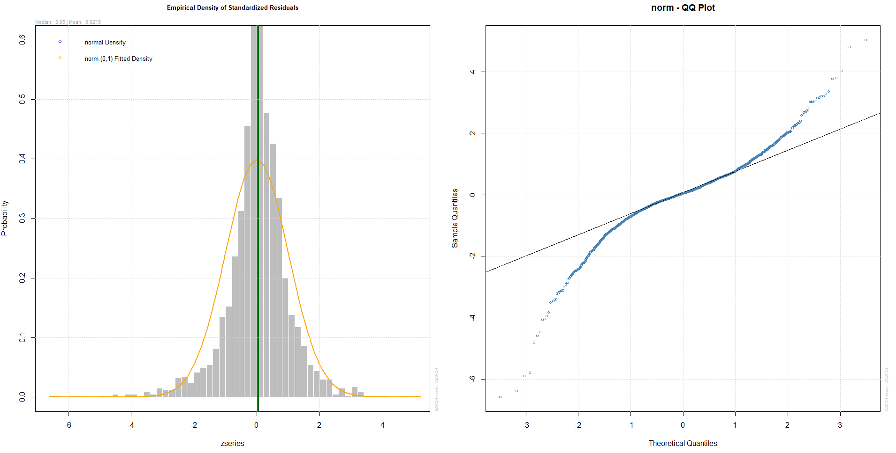

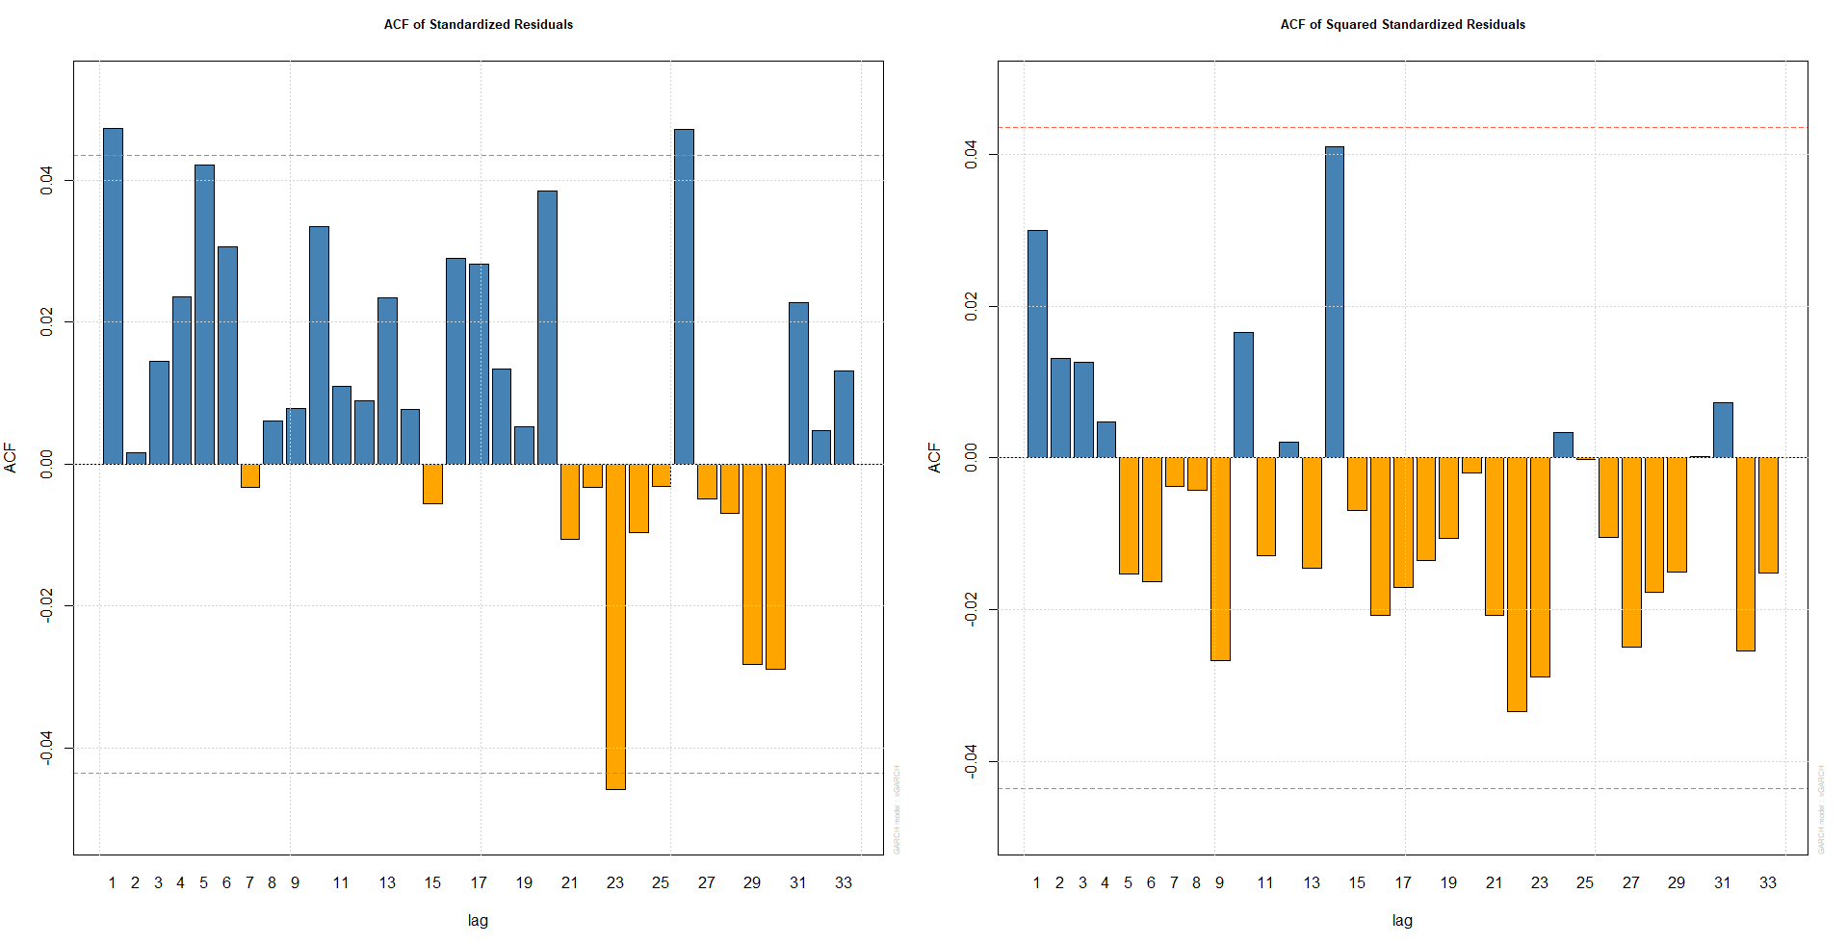

##### ARIMA(12,1,8) + GARCH(8,5)

model.1218_85<- modelfit(c(8,5), c(12,8), diff.log.bc)  
model.1218_85

##   
## *---------------------------------*  
## * GARCH Model Fit *  
## *---------------------------------*  
##   
## Conditional Variance Dynamics   
## -----------------------------------  
## GARCH Model : sGARCH(8,5)  
## Mean Model : ARFIMA(12,0,8)  
## Distribution : norm   
##   
## Optimal Parameters  
## ------------------------------------  
## Estimate Std. Error t value Pr(>|t|)  
## ar1 -0.177018 0.105555 -1.677026 0.093537  
## ar2 -0.476569 0.027320 -17.443757 0.000000  
## ar3 -0.757160 0.061515 -12.308632 0.000000  
## ar4 -0.089520 0.063729 -1.404699 0.160111  
## ar5 -0.546938 0.056996 -9.596035 0.000000  
## ar6 -0.801475 0.034768 -23.052312 0.000000  
## ar7 -0.010695 0.100408 -0.106519 0.915170  
## ar8 -0.306216 0.047565 -6.437877 0.000000  
## ar9 0.071575 0.033833 2.115534 0.034384  
## ar10 0.007715 0.026229 0.294139 0.768651  
## ar11 0.041739 0.024148 1.728484 0.083901  
## ar12 0.057338 0.027191 2.108755 0.034966  
## ma1 0.201010 0.101706 1.976380 0.048112  
## ma2 0.495956 0.014254 34.795074 0.000000  
## ma3 0.798430 0.054596 14.624376 0.000000  
## ma4 0.102806 0.054361 1.891196 0.058598  
## ma5 0.553493 0.048565 11.396963 0.000000  
## ma6 0.928562 0.000353 2626.842856 0.000000  
## ma7 0.038155 0.086943 0.438848 0.660772  
## ma8 0.359016 0.036827 9.748733 0.000000  
## omega 0.000088 0.000047 1.872452 0.061144  
## alpha1 0.149495 0.024541 6.091662 0.000000  
## alpha2 0.047620 0.027591 1.725915 0.084363  
## alpha3 0.062021 0.028711 2.160181 0.030759  
## alpha4 0.000000 0.014576 0.000002 0.999998  
## alpha5 0.170017 0.036566 4.649633 0.000003  
## alpha6 0.000000 0.110468 0.000000 1.000000  
## alpha7 0.000000 0.042314 0.000000 1.000000  
## alpha8 0.000000 0.025711 0.000000 1.000000  
## beta1 0.000000 0.151663 0.000000 1.000000  
## beta2 0.000000 0.062547 0.000000 1.000000  
## beta3 0.000000 0.107703 0.000000 1.000000  
## beta4 0.059888 0.031857 1.879899 0.060122  
## beta5 0.503893 0.056554 8.909974 0.000000  
##   
## Robust Standard Errors:  
## Estimate Std. Error t value Pr(>|t|)  
## ar1 -0.177018 0.227525 -0.778017 0.436559  
## ar2 -0.476569 0.037659 -12.654732 0.000000  
## ar3 -0.757160 0.142086 -5.328878 0.000000  
## ar4 -0.089520 0.117956 -0.758933 0.447893  
## ar5 -0.546938 0.113011 -4.839696 0.000001  
## ar6 -0.801475 0.059514 -13.466984 0.000000  
## ar7 -0.010695 0.335074 -0.031919 0.974536  
## ar8 -0.306216 0.081377 -3.762934 0.000168  
## ar9 0.071575 0.064310 1.112966 0.265723  
## ar10 0.007715 0.056141 0.137419 0.890699  
## ar11 0.041739 0.028173 1.481514 0.138470  
## ar12 0.057338 0.055927 1.025236 0.305252  
## ma1 0.201010 0.211228 0.951622 0.341289  
## ma2 0.495956 0.019234 25.786004 0.000000  
## ma3 0.798430 0.153346 5.206721 0.000000  
## ma4 0.102806 0.085122 1.207760 0.227140  
## ma5 0.553493 0.101393 5.458900 0.000000  
## ma6 0.928562 0.001136 817.291226 0.000000  
## ma7 0.038155 0.248327 0.153647 0.877888  
## ma8 0.359016 0.071860 4.996082 0.000001  
## omega 0.000088 0.000274 0.322405 0.747146  
## alpha1 0.149495 0.042632 3.506632 0.000454  
## alpha2 0.047620 0.109143 0.436307 0.662614  
## alpha3 0.062021 0.084150 0.737032 0.461103  
## alpha4 0.000000 0.072304 0.000000 1.000000  
## alpha5 0.170017 0.152242 1.116760 0.264097  
## alpha6 0.000000 0.652665 0.000000 1.000000  
## alpha7 0.000000 0.295622 0.000000 1.000000  
## alpha8 0.000000 0.150127 0.000000 1.000000  
## beta1 0.000000 0.798105 0.000000 1.000000  
## beta2 0.000000 0.307960 0.000000 1.000000  
## beta3 0.000000 0.256563 0.000000 1.000000  
## beta4 0.059888 0.145743 0.410914 0.681135  
## beta5 0.503893 0.264128 1.907758 0.056422

Optimal parameters in this model shows that alpha1, alpha3, alpha5 and beta5 are significant at 5% level.

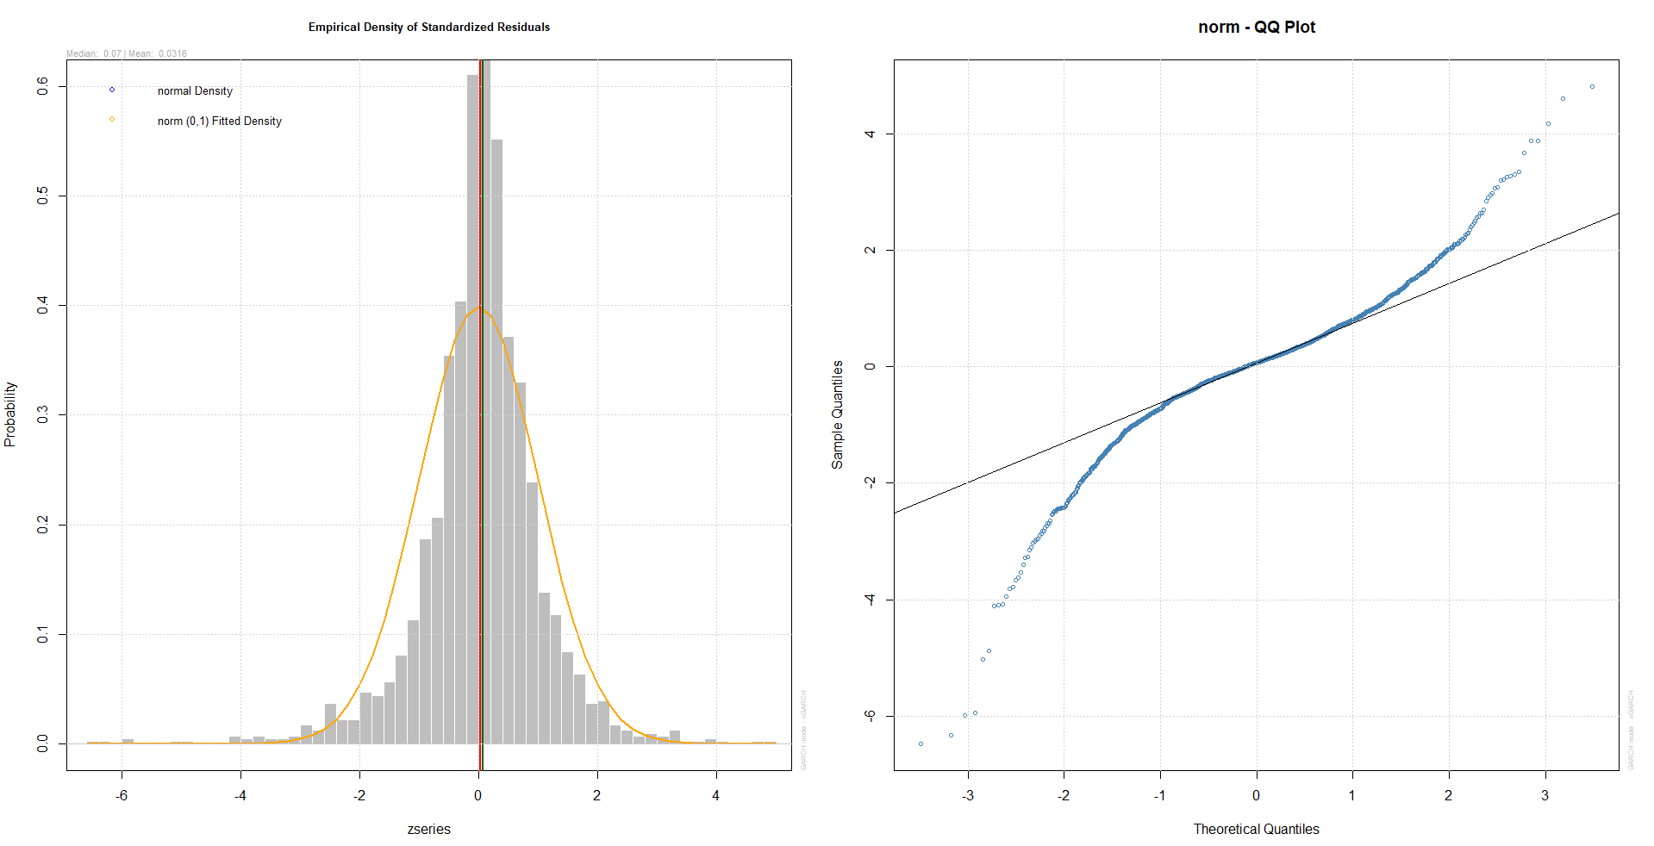

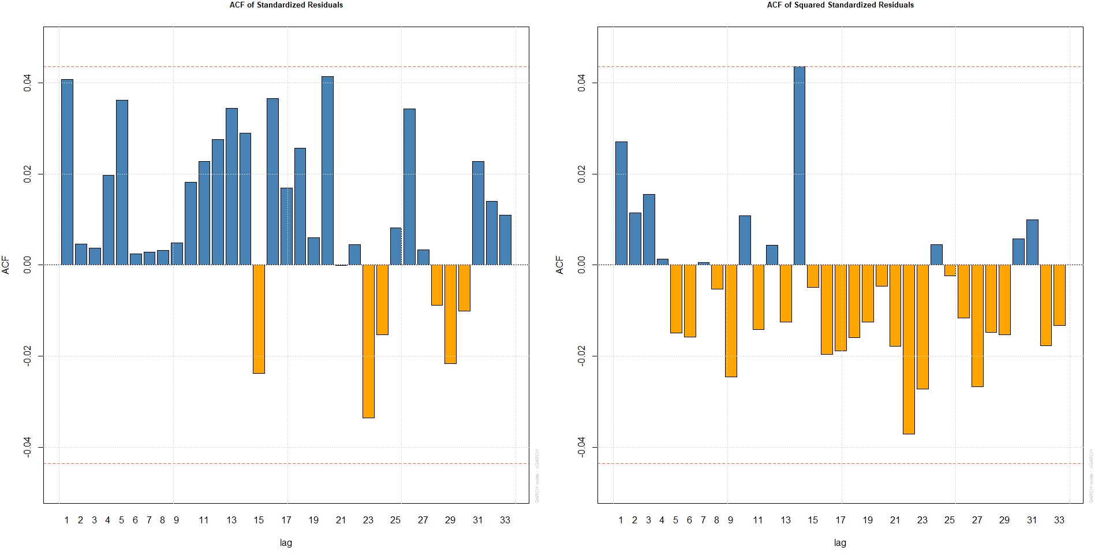

##### ARIMA(12,1,8) + GARCH(7,6)

model.1218_76 <- modelfit(c(7,6), c(12,8), diff.log.bc)  
model.1218_76

##   
## *---------------------------------*  
## * GARCH Model Fit *  
## *---------------------------------*  
##   
## Conditional Variance Dynamics   
## -----------------------------------  
## GARCH Model : sGARCH(7,6)  
## Mean Model : ARFIMA(12,0,8)  
## Distribution : norm   
##   
## Optimal Parameters  
## ------------------------------------  
## Estimate Std. Error t value Pr(>|t|)  
## ar1 0.115408 0.000028 4.1551e+03 0.000000  
## ar2 0.816645 0.000105 7.7834e+03 0.000000  
## ar3 -0.618975 0.000084 -7.3577e+03 0.000000  
## ar4 -0.248550 0.000043 -5.7852e+03 0.000000  
## ar5 0.389884 0.000060 6.5499e+03 0.000000  
## ar6 -0.178599 0.000035 -5.1499e+03 0.000000  
## ar7 0.370237 0.000062 5.9426e+03 0.000000  
## ar8 0.234662 0.000044 5.3701e+03 0.000000  
## ar9 0.045525 0.000018 2.4671e+03 0.000000  
## ar10 0.071095 0.000023 3.1447e+03 0.000000  
## ar11 -0.056466 0.000021 -2.7394e+03 0.000000  
## ar12 0.003468 0.000009 3.9663e+02 0.000000  
## ma1 -0.092192 0.000037 -2.4951e+03 0.000000  
## ma2 -0.819347 0.000121 -6.7630e+03 0.000000  
## ma3 0.639333 0.000100 6.4234e+03 0.000000  
## ma4 0.258129 0.000058 4.4678e+03 0.000000  
## ma5 -0.463171 0.000082 -5.6335e+03 0.000000  
## ma6 0.297329 0.000069 4.3118e+03 0.000000  
## ma7 -0.341556 0.000078 -4.3638e+03 0.000000  
## ma8 -0.383115 0.000074 -5.1741e+03 0.000000  
## omega 0.000064 0.000004 1.4843e+01 0.000000  
## alpha1 0.133884 0.010987 1.2186e+01 0.000000  
## alpha2 0.054275 0.022633 2.3981e+00 0.016482  
## alpha3 0.051108 0.004346 1.1759e+01 0.000000  
## alpha4 0.000131 0.005244 2.5074e-02 0.979996  
## alpha5 0.167232 0.016632 1.0055e+01 0.000000  
## alpha6 0.000099 0.044712 2.2210e-03 0.998228  
## alpha7 0.000073 0.048336 1.5110e-03 0.998795  
## beta1 0.000191 0.254705 7.5100e-04 0.999401  
## beta2 0.000129 0.205221 6.2600e-04 0.999500  
## beta3 0.000154 0.196459 7.8600e-04 0.999373  
## beta4 0.062904 0.091038 6.9097e-01 0.489588  
## beta5 0.528089 0.035299 1.4960e+01 0.000000  
## beta6 0.000148 0.166509 8.9200e-04 0.999289  
##   
## Robust Standard Errors:  
## Estimate Std. Error t value Pr(>|t|)  
## ar1 0.115408 0.000121 9.5494e+02 0.00000  
## ar2 0.816645 0.001246 6.5549e+02 0.00000  
## ar3 -0.618975 0.001234 -5.0169e+02 0.00000  
## ar4 -0.248550 0.000169 -1.4709e+03 0.00000  
## ar5 0.389884 0.000361 1.0811e+03 0.00000  
## ar6 -0.178599 0.000123 -1.4539e+03 0.00000  
## ar7 0.370237 0.000150 2.4683e+03 0.00000  
## ar8 0.234662 0.000163 1.4390e+03 0.00000  
## ar9 0.045525 0.000066 6.9498e+02 0.00000  
## ar10 0.071095 0.000091 7.8545e+02 0.00000  
## ar11 -0.056466 0.000076 -7.3825e+02 0.00000  
## ar12 0.003468 0.000012 2.9443e+02 0.00000  
## ma1 -0.092192 0.000129 -7.1656e+02 0.00000  
## ma2 -0.819347 0.000479 -1.7117e+03 0.00000  
## ma3 0.639333 0.000393 1.6257e+03 0.00000  
## ma4 0.258129 0.000151 1.7114e+03 0.00000  
## ma5 -0.463171 0.000207 -2.2357e+03 0.00000  
## ma6 0.297329 0.000313 9.5035e+02 0.00000  
## ma7 -0.341556 0.000356 -9.5830e+02 0.00000  
## ma8 -0.383115 0.000255 -1.5003e+03 0.00000  
## omega 0.000064 0.000082 7.9022e-01 0.42940  
## alpha1 0.133884 0.099640 1.3437e+00 0.17905  
## alpha2 0.054275 0.100596 5.3954e-01 0.58952  
## alpha3 0.051108 0.051733 9.8792e-01 0.32319  
## alpha4 0.000131 0.078701 1.6710e-03 0.99867  
## alpha5 0.167232 0.102870 1.6257e+00 0.10402  
## alpha6 0.000099 0.279021 3.5600e-04 0.99972  
## alpha7 0.000073 0.333197 2.1900e-04 0.99982  
## beta1 0.000191 0.703202 2.7200e-04 0.99978  
## beta2 0.000129 1.217294 1.0600e-04 0.99992  
## beta3 0.000154 1.177146 1.3100e-04 0.99989  
## beta4 0.062904 0.567052 1.1093e-01 0.91167  
## beta5 0.528089 0.075630 6.9825e+00 0.00000  
## beta6 0.000148 0.687601 2.1600e-04 0.99983  
##

Optimal parameters in this model shows that omega, alpha1, alpha2, alpha3, alpha5 and beta5 are significant at 5% level.

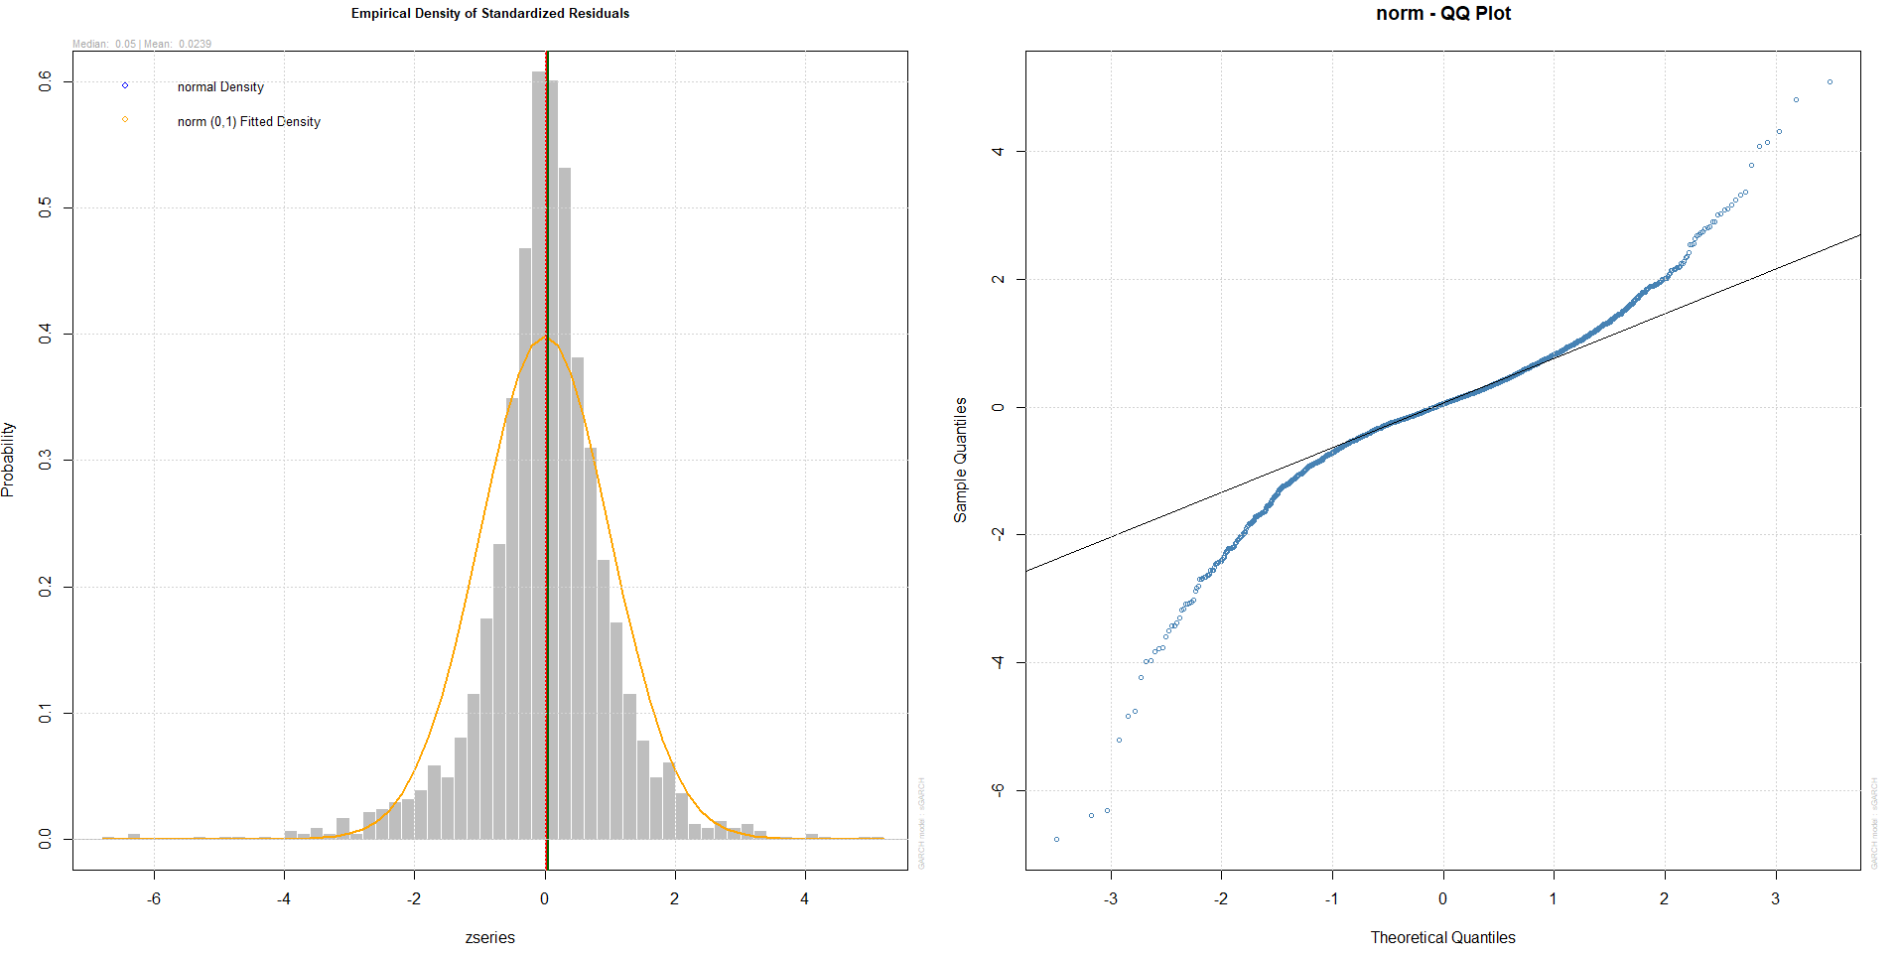

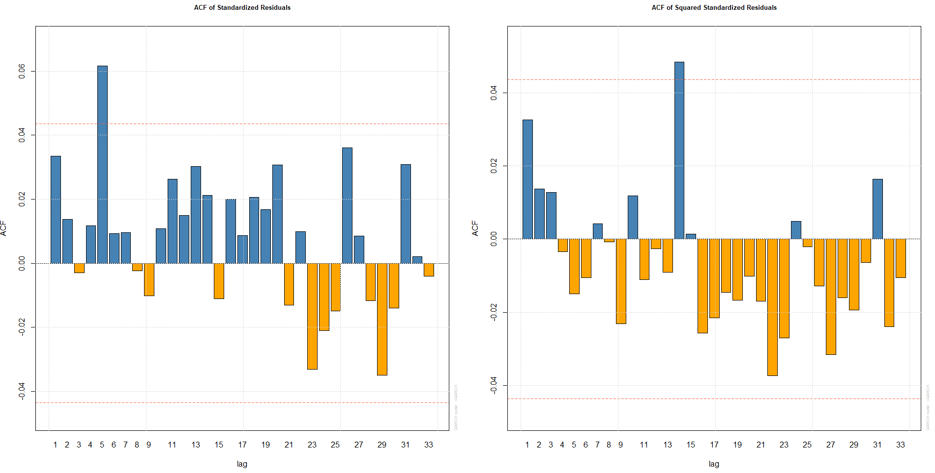

Looking at Q-Q plot between three above models, there are still many points at both tails. However ACF Plots show that ARIMA(12,1,8) + GARCH(8,5) looks better than the other. Furthermore, ARIMA(12,1,8) + GARCH(7,5) has number of significant paramters larger than these one in other model.

As a result, ARIMA(12,1,8) + GARCH(7,5) and ARIMA(12,1,8) + GARCH(8,5) are the suitable models for residuals of ARIMA(12,1,8)

# Validation

In this step, three models ARIMA(6,1,8) + GARCH(7,6) ,ARIMA(12,1,8) + GARCH(7,5) and ARIMA(12,1,8) + GARCH(8,5) are considered to validate by using MASE for forecasting values.

actual_result <- read.csv("Bitcoin_Prices_Forecasts.csv")  
observed <- as.numeric(actual_result$Closing.price)

*ARIMA(6,1,8) + GARCH(7,6)*

checkMASE(model.618_76, diff.log.bc, log.bc, observed)

## MASE  
## 1 1.356283

*ARIMA(12,1,8) + GARCH(7,5)*

checkMASE(model.1218_75, diff.log.bc, log.bc, observed)

## MASE  
## 1 2.396508

*ARIMA(12,1,8) + GARCH(8,5)*

checkMASE(model.1218_85, diff.log.bc, log.bc, observed)

## MASE  
## 1 4.892222

MASE of ARIMA(6,1,8) + GARCH(7,6) is smaller than MASE of other models. Therefore ARIMA(6,1,8) + GARCH(7,6) is the good one

# CONCLUSION

Model ARIMA(6,1,8) + GARCH (7,6) is the best model. Its predicted values for next 10 days as below

forcRes = ugarchforecast(model.618_76, data = data_model, n.ahead = 10)  
data.frame(fitted.values(forcRes, log.bc))

## fitted.values.forcRes..log.bc.  
## 1 3812.285  
## 2 3813.473  
## 3 3827.240  
## 4 3825.148  
## 5 3830.352  
## 6 3827.937  
## 7 3836.334  
## 8 3837.198  
## 9 3837.165  
## 10 3842.687

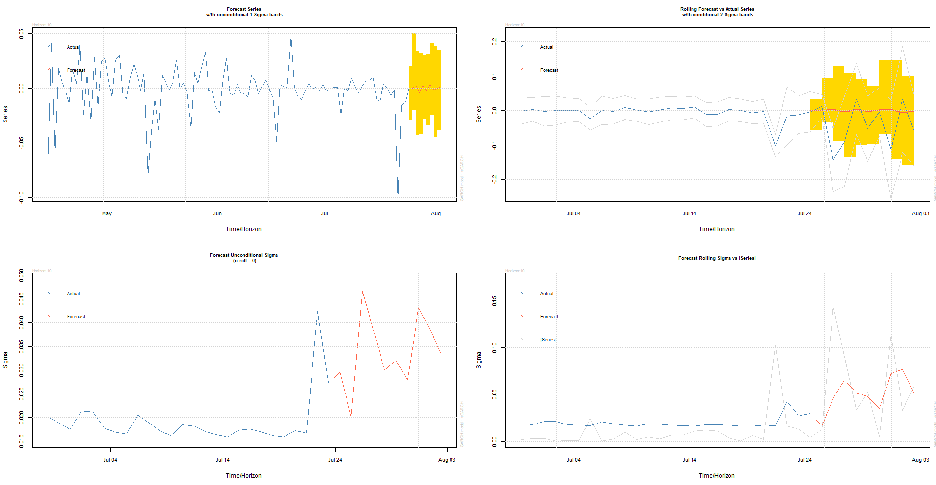

MASE of ARIMA(6,1,8) + GARCH(7,6) is 1.356283